Save money on travel, shopping, and more as a ROCKS/AUSA Member
Susan Rubel
Director, AUSA Affinity Programs

The Association of the United States Army (AUSA) is excited about the relationship with The ROCKS, Inc.! As an Association Teammate, ROCKS members receive AUSA benefits, which include professional development opportunities, meetings and events, educational and news publications, exclusive scholarship access, member savings, and more. Please visit www.ausa.org for the full range of our offerings, and download your copy of the member benefits guide at www.ausa.org/guide.
A quick way to access the Member Savings online is at www.ausa.org/savings. This allows you to click and activate your member discounts. Comments, questions, or suggestions? Please contact me at AUSA, at srubel@ausa.org. Here are some highlights:

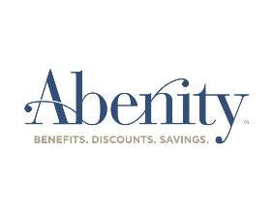
Abenity. A direct-to-member discount program offering more than 302,000 national and local discounts … many are likely to be places you shop already. Abenity represents the buying power of more than 45 million members, so they’re able to negotiate excellent savings with both local and national retailers. With more than 302,000 offers, you’re sure to find merchants you already know and love. Categories include movie tickets, attractions and tours, smart phones, health and wellness, travel, concerts and events, fashion and beauty, unique experiences, automotive, electronics, gifts and flowers, and restaurants. Start saving at www.ausa.org/abenity.
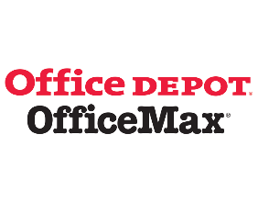
Office Depot and Office Max Discounts. If you have any printing needs, take advantage of your discount at Office Depot and Office Max. Black and white printing is 2.5 cents, and color copies are 22 cents with your member discount. Binding, folding and cutting are discounted 35% from retail. Whether you need school supplies, office supplies, cleaning supplies or coffee pods, you’ll save on more than 93,000 items with discounts up to 75%. Learn more at www.ausa.org/office, where you’ll also find a link to download your member discount card to take into your local store.
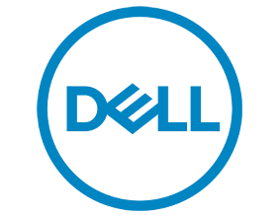
Electronics – Members receive discounts at Apple, Dell, and HP, and on McAfee® Total Protection.™
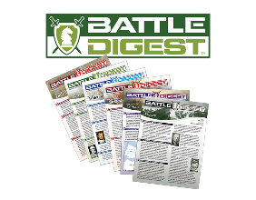
Battle Digest. Members receive a free digital subscription to Battle Digest, an executive summary of history’s important battles including lessons on strategy, tactics and leadership. The current issue is on Cannae. You’ll learn about opposing forces, historical significance, strategy and maneuvers, tactics of the battle and lessons learned.
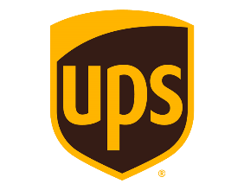
UPS Discounts. Don’t pay more than you need to for shipping. AUSA members get savings of up to 50% off on regular UPS shipping costs. You create an account, print your prepaid label at home, and drop it off at any UPS Store or request a pick-up. If your business has a UPS account, you can add the AUSA member discount to your current program. For heavy shipments, savings start at 75% with UPS Freight. Visit www.ausa.org/ups.
Entertainment Discounts. Heading to Disney or Universal Studios? While a military discount will give you the best prices on Disney tickets, AUSA’s entertainment discounts through MemberDeals can be the next best thing—especially if you aren’t eligible for a military discount, or need more tickets than allowed with your military discount. Discounts are best on multiple-day passes. Visit www.ausa.org/entertain to save up to 60% off movie theater tickets, Broadway shows, concert tickets, ski and golf get-aways, and more.

Savings on Dental, Prescription, Vision, Chiropractic and More
If you don’t have dental insurance, a dental discount plan can be an excellent option for you. Save 15% to 50% per visit on dental services including cleanings, x-rays, crowns, root canals, fillings and more. With more than 238,000 dental practice locations nationwide, it’s possible your own dentist participates. The dental plan is $5.97 per month and includes a prescription discount card. For a few dollars more you can add discounts on vision, chiropractic, lab testing, MRI & CT scans, telemedicine and health advocacy services. Visit www.ausa.org/dma.
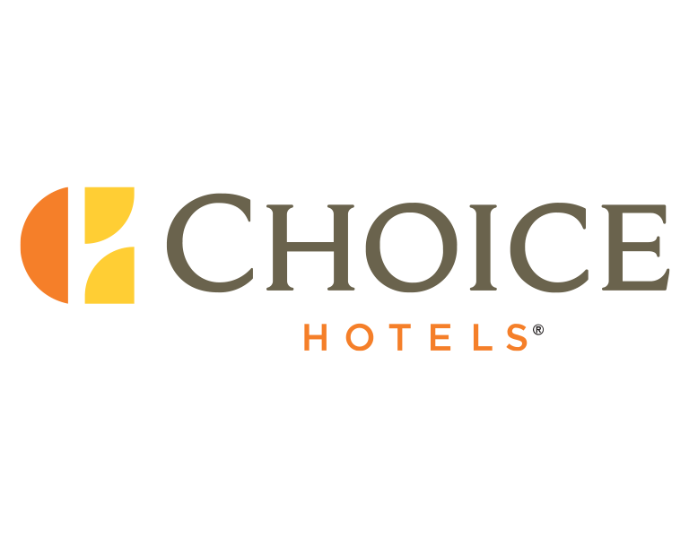
Travel Savings. Save up to 60% off hotel rates with our wholesale hotel program, allowing you to compare prices between other hotel discount sites on more than 600,000 properties worldwide. Most major hotel chains are included in this discount program. Visit www.ausa.org/hotelclub to create your account today.
Choice Hotels provides members with discounts up to 20% at their brands which include Ascend, Cambria, Clarion, Comfort Inn and Comfort Suites, EconoLodge, Mainstay Suites, Quality Inn, Rodeway Inn, Sleep Inn and Suburban Extended State.
Already have a military discount? Some of our savings partners provide a discount above the military rate. For example, our savings partner Red Roof will give you a 10%-15% military discount, but with AUSA code 622590, you’ll receive their best discount: 20% off for AUSA Members. Visit www.ausa.org/red for information and remember – pets stay free at Red Roof.
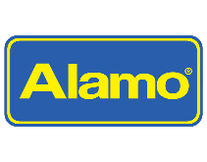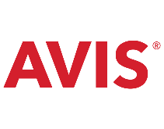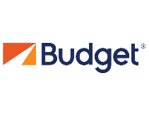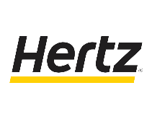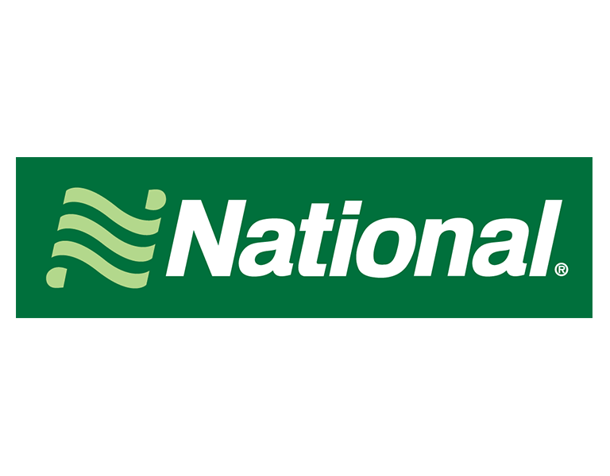
While you’re traveling, use your member discount on car rentals. You’ll receive a discount at Alamo, Avis, Budget, Enterprise, Hertz and National, and most have additional coupons you can add for a free class upgrade, free day rental, and more. You can access them all from the AUSA member savings page at www.ausa.org/savings. And don’t forget Budget Truck Rental if you’re moving, with 15% savings on Fridays and Saturdays, and 20% savings Sunday through Thursday.
Educational Savings. If you’re planning to go back to school to improve or update your skills, take advantage of our relationships with edX, UMUC, and Trident University. edX is a non-profit formed by MIT and Harvard that provides classes from some of the best schools in the world, such as RIT, Microsoft, MIT, Harvard, Berkeley, Boston University and many more. Save 20% off paid classes and verified certificates with code edXAUSA. UMUC provides members 20% off out-of-state tuition on most programs and waives the application fee. And Trident University provides members substantial discounts on tuition, up to 39%.
SAT/ACT Test Prep. Are you, or someone you know, preparing for SATs and ACTs? Consider the SAT and ACT PowerPrep™ program, selected by the National Federation of High Schools for its 19,500-member high schools. It’s a comprehensive prep program that members and their family members receive ($350 and $700 retail) for a service fee to cover the cost of streaming and customer support. All fees are reinvested to improve the program. Access 74+ hours of video instruction, and thousands of interactive diagnostic lessons and questions. Plus, chat with teachers live and explore a new expanded math section. LSAT prep materials are also available.
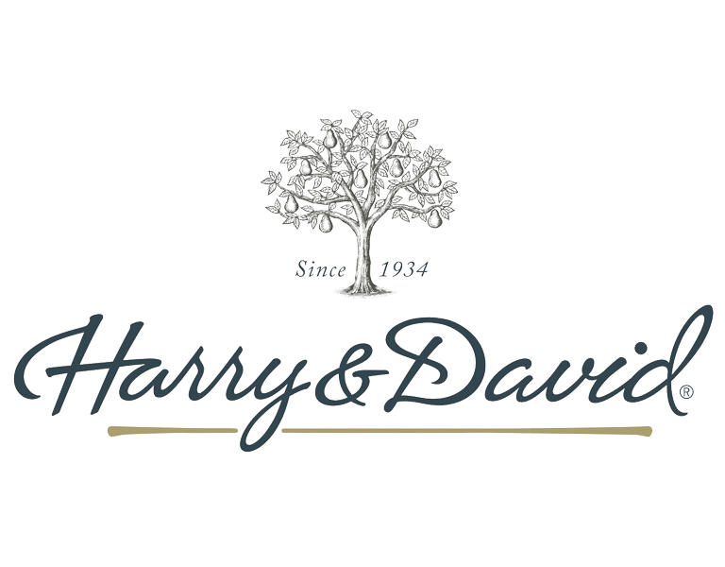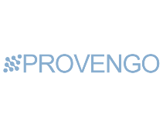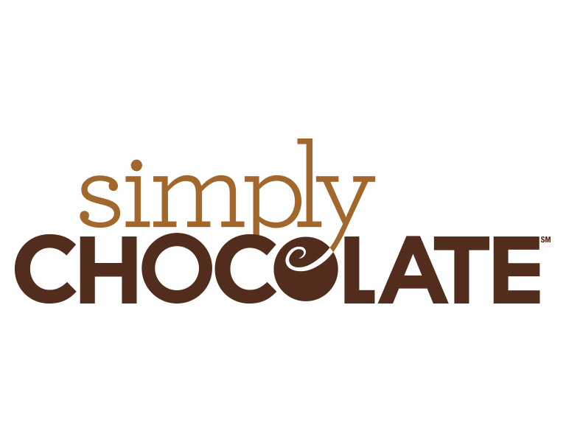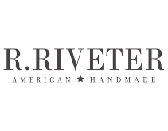
Holiday and Gift-Giving Discounts. Many gourmet food and other gift companies provide discounts to members including 1800Baskets, Cheryl’s Cookies, Fruit Bouquets, Harry & David, Personalization Universe, The Popcorn Factory, Simply Chocolate, Stock Yards, and Wolferman’s. Also consider R.Riveter for beautiful products made by military spouses. Members also have access to Provengo, a private e-commerce site, not available to the public, which provides discounts on products like YETI, Under Armor, Shimano, Benchmade, Costa and more.
Insurance – The ROCKS, Inc. members may participate in AUSA’s insurance programs, which include a Group Term Life Plan with coverage up to $500,000, an Accidental Death & Dismemberment plan and a TRICARE Supplement which pays your cost-share after deductibles.

